Project Design Phase-I
Solution Architecture

Date | 26 October 2026
Team ID
Project Name | Electric Vehicle Market Performance & Insights
Maximum Marks | 4 Marks

Solution Architecture:
Solution architecture is a complex process – with many sub-processes – that bridges the gap between business problems and technology solutions. Its goals are to:
- Find the best tech solution to solve existing business problems.
- Describe the structure, characteristics, behavior, and other aspects of the software to project stakeholders.
- Define features, development phases, and solution requirements.
- Provide specifications according to which the solution is defined, managed, and delivered.

Solution Architecture Diagram – Electric Vehicle Market Performance & Insights
The diagram below represents the implemented CSV-to-Tableau-to-public-website workflow.
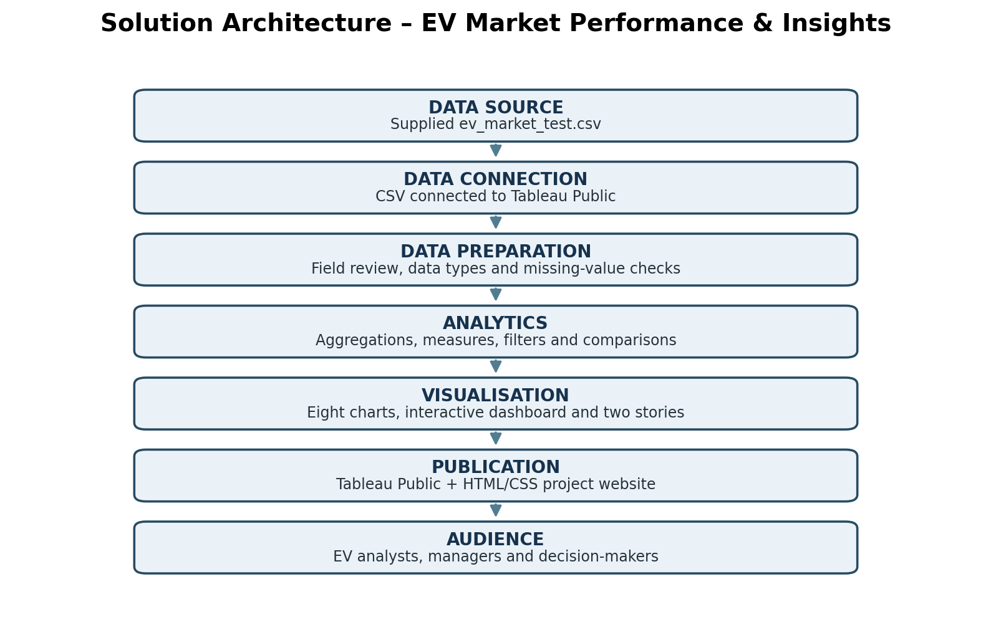
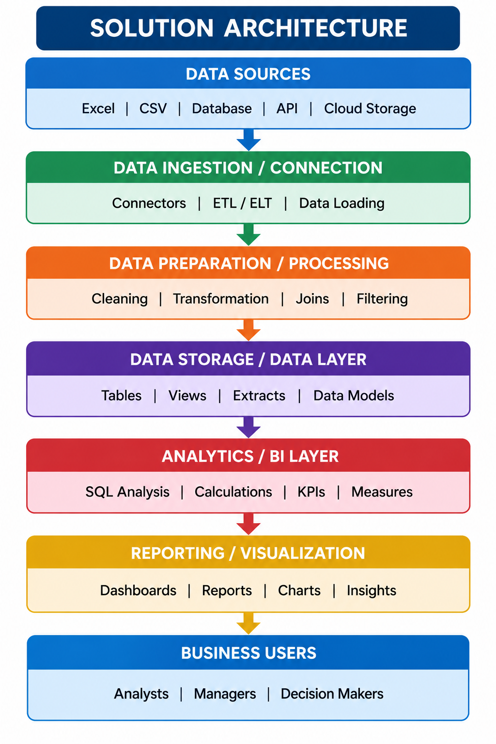

Component Description Table
Component Name | Description / Role in Architecture | Technology Used
Data source | Provides the EV records and attributes used for analysis. | Supplied CSV: ev_market_test.csv
Data connection | Loads the CSV into the analytics environment. | Tableau Public CSV connection
Data preparation | Reviews fields, data types and missing values; missing values are not treated as zero by default. | Tableau data source and worksheet preparation
Analytics and calculations | Aggregates recorded sales and calculates counts and averages for comparisons. | Tableau dimensions, measures, aggregations and filters
Visualisation and reporting | Presents eight charts in an interactive dashboard and two explanatory stories. | Tableau Public
Web presentation | Provides public project overview and links/embed to dashboard and stories. | HTML and CSS
Version control and hosting | Stores project files and publishes the website. | GitHub repository and GitHub Pages
Component Name | Description / Role in Architecture | Technology Used

